Network Design Proposal
Network Design Proposal

Prepared for:
University of Maryland University College

Prepared by:
Student Name

I. Network Design

A. Network Topology

Technical Requirements

In this space, the network topology exhibits the course of the physical arrange usage and represents the $64000 functions of the system design, which includes the gadgets, areas, and link institution.
In the two server rooms of the structure, the centralized server and founded. The centralized pc interfaces with the servers. The overall changes from the distinctive floors at that time keep company with the centralized server.
The physical style has subsequent features:
• The building is outfitted with class 6e cabling and divider plates within the workplaces, study halls, labs, etc.
• There are Cat half-dozen cabling and divider plates fitted within the lecture rooms, library and therefore the workplaces
• at intervals, the structure, oversaw switches are used. Overseen switches provide massive power over local area network traffic and offer propelled highlights to manage that traffic. It offers the capability to rearrange, oversee, and screen local area network and this offers a lot of distinguished power over however data goes over the system and UN agency approaches it (Morales, Ruiz, & Velasco, 2017). Also, oversaw switches use conventions, as an example, the straightforward Network Management Protocol, or what we have a tendency to decision SNMP, for checking the gadgets on the system. SNMP may be a convention that encourages the commerce of the executive information between system gadgets. SNMP queries will decide the soundness of the system or the standing of a selected widget. By showing this data in associate degree effectively gotten an arrangement, IT administrators set at a focal web site will screen the execution of the system and speedily acknowledge and fix organize problems while not having to collaborate with the switch physically.
• A separate switch is used on the different floor. Thusle|the only|the only real} reason for this switch is to handle the VLAN of the varsity so as to keep the understudies from progressing to the essential information of the, as an example, authoritative information.
• The ISP represents net Service supplier. These are organizations that provide access to the net.
• The firewall may be a widget supposed to permit or deny organize transmissions addicted to plenty of tenets and is each currently and once more conventional protect systems from unapproved get to whereas allowing real correspondences to pass.
Proposed Topology

A star topology is a topology for a Local Area Network (LAN) in which all hubs are independently associated with a focal association point, similar to a center or a switch. A star takes more link than for example a mode of transport, however, the advantage is that if a link flops, just a single hub will be cut down (Morales, Ruiz, & Velasco, 2017)
In this setup, each hub interfaces with a focal system gadget, similar to a center, switch, or PC. The focal system gadget goes about as a server and the fringe gadgets go about as customers. Contingent upon the sort of system card utilized in every PC of the star topology, a coaxial link or an RJ-45 organize link is utilized to interface PCs together (Morales, Ruiz, & Velasco, 2017).
Advantages of the star topology
- Centralized the board of the system, using the focal PC, center, or switch.
- Easy to add another PC to the system.
- If one PC on the system falls flat, the remainder of the system keeps on working regularly.
Disadvantages of the star topology
- May have a more significant expense to actualize, mainly when utilizing a switch or switch as the focal system gadget.
- The focal system gadget decides the execution and number of hubs the system can deal with.
- If the focal PC, center point, or switch fizzles, the whole system goes down and all PCs are separated from the system.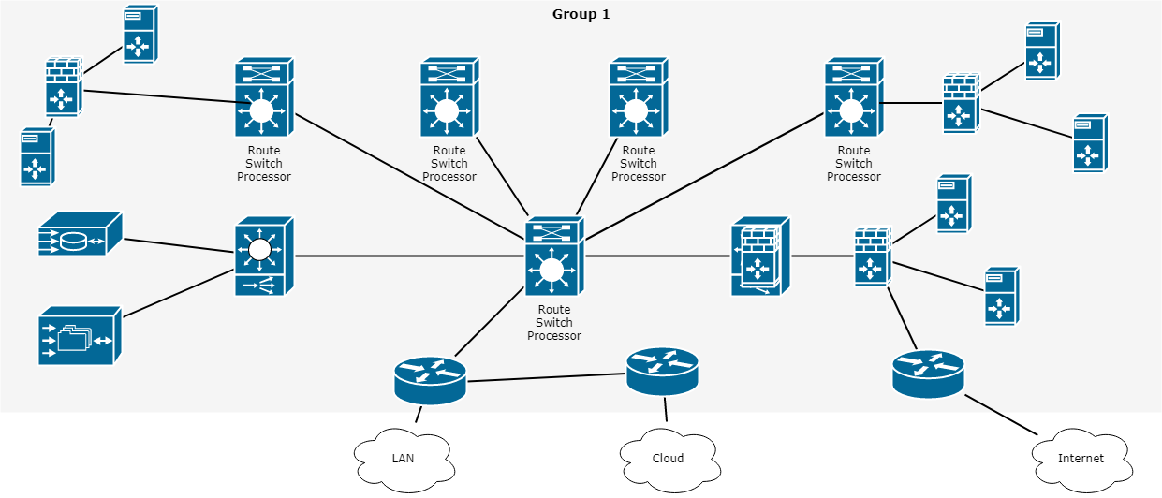

Justification

Star topology is a network topology where every individual bit of a system is connected to a focal hub (frequently called a center point or switch). The connection of these system pieces to the focal segment is outwardly spoken to in a structure like a star. All traffic radiates from the center of the star. The focal site is responsible for every one of the hubs joined to it. The focal center point is typically a quick, independent PC and is in charge of steering all traffic to different hubs (Morales, Ruiz, & Velasco, 2017). The primary preferences of a star arrange is that one failing hub does not influence the remainder of the system. In any case, this kind of system can be inclined to bottleneck and disappointment issues at the local site.

B. Cables and Connectors

Technical Requirements

Cat 6 links or to give them their full name class 6 link is the current favored link type for LAN system and phone wiring where curved pair cabling is required. Cat 6 links comprise of an unshielded link containing four contorted sets, regularly of 24 check wire. The ending connector is an RJ-45 jack. In perspective on this these Cat5 organize links are periodically alluded to as RJ45 arrange links or RJ45 fix links. Ensured Cat-6 links will have the wording "Cat 6" composed as an afterthought. As they adjust to EIA/TIA 568A-5, this is composed on the external sheath. It is in every case best to utilize the suitable system links when setting up a system as flawed or not to standard links can cause issues that might be hard to recognize and follow (Pan et al, 2017).
Cat 6 arrange link is currently the standard type of wound pair link and overrides Cat 3. The Cat 6 links can be utilized for information accelerates to 125 Mbps, in this way empowering them to help 100Base-T which has a most extreme information speed of 100 Mbps while the Cat-3 link was intended to be good with 10Base-T. The Cat6 link can bolster working up to lengths of 100 meters at the full information rate (Pan et al, 2017)..
Where it is important to work at higher rates, as on account of Gigabit Ethernet, an upgraded rendition of Cat 6 link known as Cat 6e is frequently suggested, in spite of the fact that Cat 6 is determined to work with Gigabit Ethernet, 1000Base-T. On the other hand, Cat 6e can be utilized with 100Base-T to empower more noteworthy lengths (up to 350 meters) to be accomplished (Pan et al, 2017).
Proposed Cables and Connectors

Unshielded Twisted Pair (UTP) - This is the most mainstream type of links in the system and the least expensive structure that you can run with. The UTP has four sets of wires and all inside plastic sheathing (Yang et al, 2017). The main motivation that we call it Twisted Pair is to shield the wires from obstruction from themselves (Yang et al, 2017).. Each wire is just ensured with a dainty plastic sheath.
There are seven unique sorts of UTP classifications and, contingent upon what you need to accomplish, you would require the fitting kind of link. UTP-CAT6e is the most prevalent UTP link which came to supplant the old coaxial link that was not ready to stay aware of the steady developing requirement for quicker and progressively dependable systems (Yang et al, 2017).

Justification

The attributes of UTP are exceptionally great and make it simple to work with, introduce, grow and investigate and we are going to take a gander at the diverse wiring plans accessible for UTP, how to make a straight through UTP link, rules for safe activity and a ton of other cool stuff (Yang et al, 2017).
C. Networking and Internetworking Hardware

Technical Requirements

An internetworking gadget is a generally utilized term for any equipment inside systems that interface diverse system assets. Key gadgets that involve a system are switches, scaffolds, repeaters, and portals. All gadgets have independently introduced extension highlights; per arrange prerequisites and situations (Kumar, 2015).
Proposed Networking and Internetworking Devices
Network Hub: Network Hub is a systems administration gadget which is utilized to interface different system has. A system center point is likewise used to do information exchange. The information is moved as far as bundles on a PC arrange. Along these lines, when a host sends an information parcel to a system center point, the center duplicates the information bundle to the majority of its ports associated with (Kreutz et al, 2015). Like this, every one of the ports thinks about the information and the port for which the bundle is planned, claims the parcel.

Network Switch: As a center point, a switch likewise works at the layer of LAN (Local Area Network) yet you can say that a switch is more insightful than a center. While center point simply takes every necessary step of information sending, a switch does 'channel and sending' which is an increasingly insightful method for managing the information parcels (Kreutz et al, 2015).

Modem: A Modem is to some degree all the more intriguing system gadget in our day by day life. So, in the event that you have seen around, you get a web association through a wire (there are distinctive sorts of wires) to your home. This wire is utilized to convey our web information outside to the web world.

Network Router: A switch is a system gadget which is in charge of directing traffic starting with one then onto the next system. These two systems could be a privately-owned business system to an open system. You can think about a switch as traffic police who guides diverse system traffic to various bearings.

Bridge: If a switch associates two unique sorts of systems, at that point a scaffold interfaces two subnetworks as a piece of a similar system. You can consider two distinct labs or two unique floors associated with an extension.

Repeater: A repeater is an electronic gadget that enhances the flag it gets. In different terms, you can consider repeater a gadget which gets a flag and retransmits it at a more elevated amount or higher power with the goal that the flag can cover longer separations.

Justification
Switches are very keen system gadgets that are basically utilized for huge systems and give the best information way to viable correspondence. Switches have memory chips which store extensive amounts of system addresses.
Extensions are utilized to interface two substantial systems by giving distinctive system administrations.
Repeaters are utilized for flag and information recovery and are basically in charge of information enhancement.
Passages are internetworking gadgets used to change over arrangements and are the foundation of any system design.

D. Wide Area Network (WAN) Design

Technical Requirements

In this section, you'll assess UMUC's technical needs associated with the Wide space Network (WAN) style. you'll build assumptions wherever applicable. once creating assumptions, list every and confirm to justify the answer within the Justification section.

Proposed Wide Area Network (WAN) Design

A Wide Area Network (WAN) is a PC organizes covering numerous separation regions, which may spread over the whole world. WANs regularly interface different littler systems, for example, neighborhood (LANs) or metro region systems (MANs) (Kreutz et al, 2015). The world's most mainstream WAN is the Internet. A few sections of the Internet are likewise WANs in themselves. The key contrast among WAN and LAN advances are versatility. C WAN must most likely develop as expected to cover different urban communities, even nations and mainlands.

A lot of switches and switches are interconnected to shape a Wide Area Network. The switches can be associated in various topologies, for example, full work and half work. A wide territory system might be exclusive or leased from a specialist organization, yet the term generally implies the consideration of open (shared client) systems.
Both parcels exchanging and circuit exchanging innovations are utilized in the WAN. Bundle changing enables clients to share normal bearer assets with the goal that the transporter can make increasingly effective utilization of its framework. In a parcel exchanging setup, systems have associations into the bearer's system, and numerous clients share the Transporter's system (Kreutz et al., 2015). The transporter would then be able to make virtual circuits between clients' destinations by which parcels of information are conveyed from one to the next through the system.
Circuit Switching enables information associations with be built up when required and after that ended when correspondence is finished. This works like a typical phone line works for voice correspondence. Incorporated Services Digital Network (ISDN) is a genuine case of circuit exchanging. At the point when a switch has information for a remote site, the exchanged circuit is started with the circuit number of the remote system (Kreutz et al, 2015).

Justification

This section ought to be accustomed to justify your planned answer supported the technical needs and assumptions.

E. Computer Systems Hardware

Technical Requirements

In this section, you may assess UMUC’s technical needs associated with the pc systems hardware for each room finish points and servers likewise as what would be required for dedicated IT use. You may have to create assumptions wherever acceptable. once creating assumptions, list every and confirm to justify the answer within the Justification section.

Proposed Computer Systems Hardware

Gadgets and media are the physical elements, or instrumentation, of the system. instrumentation contains the components of the system stage that normally are clear, for instance, a PC, PC, switch, switch, remote passage, or the cabling wont to associate the gadgets (Mestres et al., 2017). Incidentally, some system components might not be obvious. On account of remote media, as an example, messages are transmitted through the air utilizing indiscernible radio return or infrared waves (Mestres et al., 2017).

System components are utilized to present administrations and procedures. These administrations and procedures are the correspondence programs, known as programming, that keep running on the organized gadgets (Mestres et al., 2017). A system administration offers knowledge thanks to a solicitation. Administrations incorporate an outsized variety of the regular system applications people utilize daily, almost like email facilitating administrations and internet facilitating administrations. Procedures provide the utility that coordinates and moves the messages through the system (Mestres et al., 2017). Procedures are additional delicate to United States of America nevertheless are basic to the activity of systems.
Justification

This section ought to be accustomed to justify your projected answer supported the technical needs and assumptions.

II. Network Addressing and Security

A. Subnetting

Overview

Subnetting could also be a way of breaking AN oversize network into little networks observed as subnets. Subnetting happens once we have a tendency to extend the default boundary of the subnet mask. Basically, we have a tendency to tend to borrow host bits to form networks (i.e., subnets).
We have been allotted the network address 192.168.22.0. supported the chart below, we have a tendency to all grasp this could be a class C address. this could be determined by perceptive the first octet of the science address, that's 192. This octet falls in between 192 and 223 (Pan et al, 2017).
Class | Octet Decimal Range
A | 1 - 126
B | 128 - 191
C | 192 - 223

Each category contains a predefined default subnet mask that tells the United States of America the octets, that are already a part of the network portion, furthermore as what number bits we've offered to figure with.
Class | Subnet Mask | Format
A | 255.0.0.0 | Network.Host.Host.Host
B | 255.255.0.0 | Network.Network.Host.Host
C | 255.255.255.0 | Network.Network.Network.Host

CIDR (Classless Inter-Domain Routing)

● CIDR might be a slash notation of the subnet mask. CIDR tells U.S.A. the amount of on bits throughout a network address.
● Class A has default subnet mask 255.0.0.0 which suggests initial octet of the subnet mask has all on bits. In slash notation, it would be written as /8, implies that address has eight bits on.
● Class B has default subnet mask 255.255.0.0 which suggests initial two octets of the subnet mask have all on bits. In slash notation, it would be written as /16, implies that address has sixteen bits on.
● Category C has default subnet mask 255.255.255.0 which means initial 3 octets of the subnet mask have all on bits. In slash notation, it might be written as /24, means that address has twenty-four bits on Pan et al, 2017).
Technical Requirements

UMUC has not determined but they'll use all of the physical space within the contemporary hired building, but the diagrams below convey the planned end state. However, they have determined to use a variety of the realm at intervals the short term. In doing so, we'll proceed with the planned prepare. Initially, the building will house five school rooms, one student pc laboratory, 1 library, and one workplace.

● Among the below-building diagrams, we have a tendency to are visiting use geographic point 5 (Admissions) on the first floor. each geographic point will have one portable computer for staff use, with the exception of the geographic admissions point, that is in a position to own 5 computers. Supported the subnetting performed on top of, we have a tendency to tend to is {additionally} able to add additional devices among the longer term.
● the lecture areas are tagged room #1, room #2, and area #4 on the first floor and room #1 and room #5 on the second floor; each room will have a closet. each area will have twenty 5 devices: twenty 3 student computers, one professional portable computer, and one server among the closet, for academic use.
● Students should take into consideration high traffic areas for Wi-Fi, just like the sitting areas and not the lecture rooms. The Wi-Fi network should be white from the wired network and enforced on a separate class C network. what's visiting the network address, range, and broadcast address for this separate class C wireless address be?
● in addition, there'll be a student portable computer laboratory which is able to provide computer access to students to undertake and do their school assignment. the scholar portable computer laboratory is found on the second floor. There will be twenty-four computers throughout this laboratory and one server among the closet. to allow students access to library resources, the library can have 10 computers for the ultimate public to use and 5 computers for library staff (Pan et al, 2017).
there'll be two server rooms, one on the first floor and one on the second floor.
To be clear, the diagram below conveys the proposed end state.

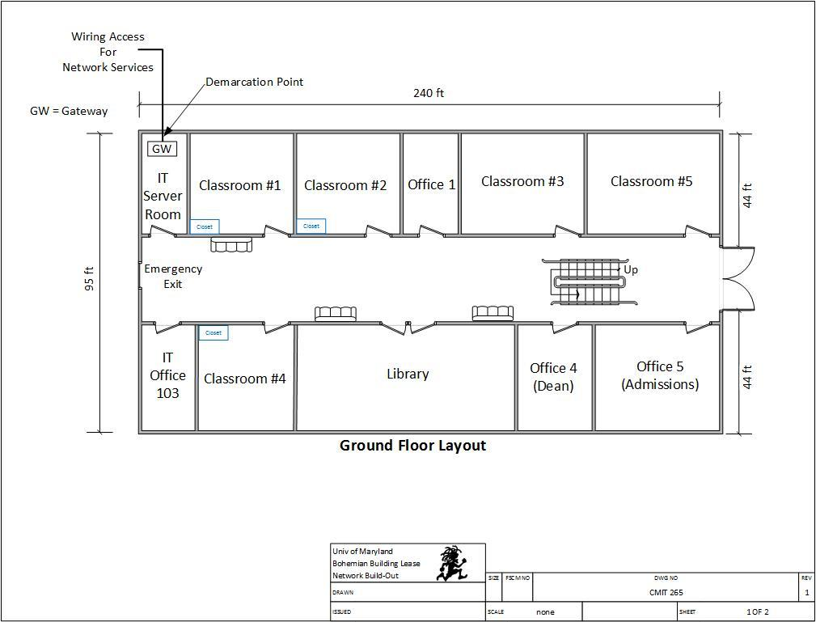

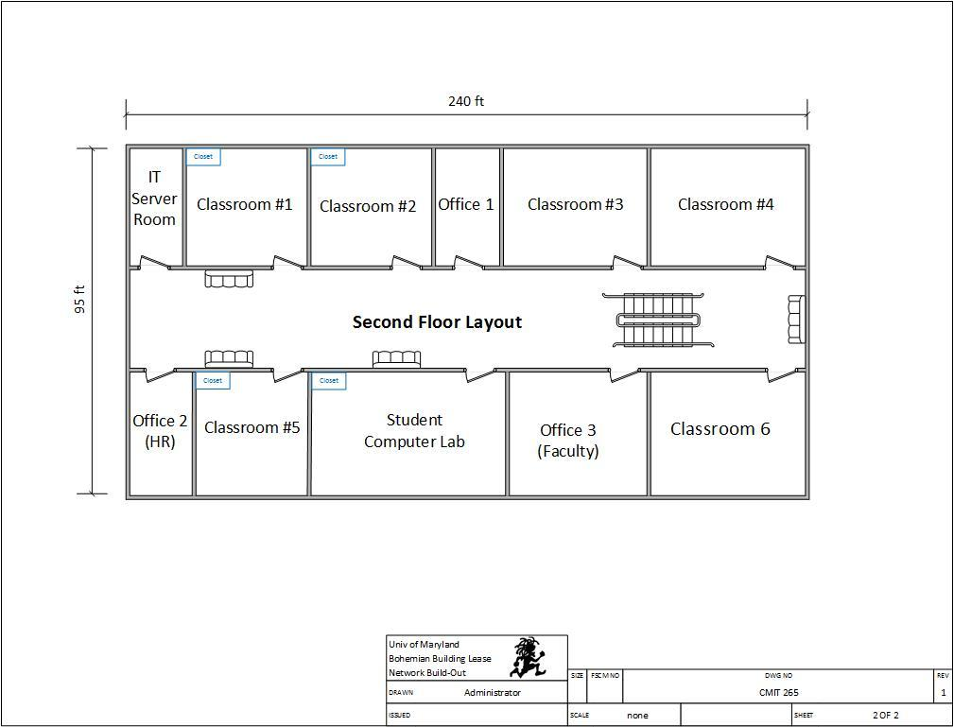

Given the identical scenario, we've got a bent to are visiting use the 192.168.3.0 network and build an entire of eight subnets, with twenty-five potential hosts on each subnet. The chart below describes structures true to include each subnet and required hosts.
Subnet Description | Required Hosts
Classroom 1 (First Floor) | 25 Computers
Classroom 2 (First Floor) | 25 Computers
Classroom 4 (First Floor) | 25 Computers
Classroom 1 (Second Floor) | 25 Computers
Classroom 5 (Second Floor) | 25 Computers
Office 5 – Admissions (Second Floor) | 25 Computers
Student Computer Lab | 25 Computers
Library | 15 Computers
Note: Using the How to Subnet a Network Video provided in CMIT 265 LEO - Content - UMUC Network Design Proposal, complete the following chart.

Proposed Subnet
Subnet | Network Address | Host Address Range | Broadcast Address
Subnet Mask: 255.255.255. ___
Classroom 1 (First Floor) | 192.168.22.0 | 192.168.22.1 - 192.168.22.30 | 192.168.22.31
Classroom 2 (First Floor) | 192.168.22.32 | 192.168.22.33 - 192.168.22.62 | 192.168.22.63
Classroom 4 (First Floor) | 192.168.22.64 | 192.168.22.65 - 192.168.22.94 | 192.168.22.95
Classroom 1 (Second Floor) | 192.168.22.96 | 192.168.22.97 - 192.168.22.126 | 192.168.22.127
Classroom 5 (Second Floor) | 192.168.22.128 | 192.168.22.129 - 192.168.22.158 | 192.168.22.159
Office 5 – Admissions (Second Floor) | 192.168.22.160 | 192.168.22.161 - 192.168.22.190 | 192.168.22.191
Student Computer Lab | 192.168.22.192 | 192.168.22.193 - 192.168.22.222 | 192.168.22.223
Library | 192.168.22.224 | 192.168.22.225- 192.168.22.254 | 192.168.22.255
Wi-Fi Network | 192.168.22.0 | 192.168.22.1 – 192.168.22.254 | 192.168.22.255
B. Firewall Implementation

Technical Requirements

In this section, you'll assess UMUC’s technical needs associated with the firewall implementation. you'll must build assumptions wherever acceptable. once creating assumptions, list every and confirm to justify the answer within the Justification section.
Proposed Firewall Implementation

Packet filtering firewall: On the net, bundle separation is that the approach toward passing or interference parcels at a system interface addicted to supply and goal locations, ports, or conventions. The procedure is employed associated with bundle devastation and Network Address Translation (NAT). Bundle separation is often a part of a firewall program for shielding a locality organizes from undesirable interruption.

In a product firewall, parcel separation is finished by a program known as a bundled channel. The parcel channel appearance at the header of each bundle addicted to a specific arrangement of pointers, and on it, premise chooses to stay it from passing (called DROP) or alter it to pass (called ACCEPT).

Justification

This section ought to be accustomed to justify your projected resolution supported the technical necessities and assumptions.

C. Intrusion Detection System / Intrusion Protection System

Technical Requirements

In this section, you'll assess UMUC’s technical necessities associated with the intrusion detection system (IDS) and Intrusion bar System (IPS). You’ll have to create assumptions wherever acceptable once creating assumptions, list every assumption and ensure to justify the answer within the Justification section (Kang, & Kang, 2016).

Proposed Intrusion Detection System / Intrusion Protection System

An IDS screens organize traffic searching down suspicious movement and notable dangers, causation up cautions once it finds such things. A semi-permanent company digital security staple, interruption identification as a capability stays basic within the advanced venture, however maybe not as associate freelance arrangement (Kang & Kang, 2016).

Interruption recognition programming frameworks will be broken into 2 general classifications: have primarily based and organize based; those two classifications address wherever sensors for the IDS are placed (on a host/endpoint or a system).

Interruption identification is inactive associate innovation; it acknowledges and recognizes a problem however go in the stream of system traffic, Novak said. "As documented, the planning is to get an alarm on imperative traffic. Associate alarm educates the IDS examiner that some intriguing traffic has been watched. Be that because it could, it's someday presently the grounds that the traffic isn't blocked or ceased in any capability from achieving its goal."

Contrast that with firewalls that shut notable malware and interruption compensative action framework (IPS) innovation, that because the name portrays, to boot squares vindictive traffic.

Despite the actual fact that associate IDS doesn't stop malware, cybersecurity specialists aforementioned the innovation still incorporates a spot within the leading edge venture.

"The quality of what it will continue to be primarily important," Eric above Hanselman, boss investigator with 451 analysis. "The IDS piece itself is thus far pertinent in light-weight of the fact that at its center it's characteristic a functioning assault."

Justification

This section ought to be accustomed to justify your projected resolution supported the technical necessities and assumptions.

D. DMZ Implementation

Technical Requirements

In this section, you'll assess UMUC's technical requirements related to the DMZ implementation. You'll produce assumptions where applicable. Once making assumptions, list each and guarantee to justify the solution at intervals the Justification section.
Proposed DMZ Implementation

This section should be accustomed to providing the most points of your planned answer, supported the special wants and assumptions. What uses would UMUC need for a DMZ? What instrumentation should be placed into the DMZ? The student should be specific once discussing the models, types, and costs.
Justification

This section ought to be accustomed to justify your projected resolution supported the technical necessities and assumptions.

E. Physical Security Measures

Technical Requirements

In this section, you'll assess UMUC's technical requirements related to physical security measures. You must produce assumptions where acceptable. Once making assumptions, list each and guarantee to justify the solution inside the Justification section.

Proposed Physical Security Measures

#1: Lock up the server room: so, even before you lock down the servers, truth be told, before you even flip them on out of the blue, you must guarantee that there are nice bolts on the server area access (Pan et al, 2017). Obviously, the simplest lock on the earth will an entire ton of nothing within the event that it isn't used. Therefore you likewise want methods necessitating that those entryways be fast whenever the area is empty, and therefore the arrangements ought to start the United Nations agency has the key or keycode to induce in.

The server area is that the core of your physical system and someone with physical access to the servers, switches, switches, links and totally different gadgets therein area will do large hurt.

#2: founded surveillance: protection the door to the server area could be a smart opening, however somebody may break in, or somebody United Nations agency has licensed access may misuse that authority. you wish the simplest way to understand United Nations agency goes in and out and once. A log book for language in and out is that the most elemental thanks to accomplishing this, however, it's lots of drawbacks. An individual with malicious intent is probably going to simply bypass it (Pan et al, 2017).

A video police investigation camera, placed during a location that produces it troublesome to tamper with or disable (or even to find) however offers an honest read of persons coming into and deed ought to supplement the log book or electronic access system. police investigation cams will monitor unendingly, or they'll use motion detection technology to record only if somebody is moving concerning. they'll even be founded to send e-mail or cellular phone notification if the motion is detected once it shouldn't be (such as once hours).

#3: confirm the first vulnerable devices are therein fast room: confine mind, it's not merely the servers you wish to fret over. A software engineer will connect a digital computer to a middle purpose and use someone programming to catch data traversing the system. make sure that but several of your system gadgets as might be expected beneath the circumstances are therein fast area, or on the off probability that they ought to be in the alternate associate region, during a secured room elsewhere within the structure.

#4: Use rackmount servers: Rackmount servers not solely take up less server area real estate; they're conjointly easier to secure. though smaller and arguably lighter than (some) tower systems, they'll simply be fast into closed racks that, once loaded with many servers, will then be fast to the ground, creating the whole package nearly not possible to maneuver, abundant less to steal.

#5: Don't forget the workstations: Programmers will utilize any unbound laptop that's related to the system to induce to or erase knowledge that is essential to your business. Workstations at abandoned work areas or in void workplaces, (for example, those used by representatives United Nations agency are within the inside of some recreation or have left the organization and not however been supplanted) or at areas effectively hospitable pariahs, as an example, the front secretary's workspace, are particularly ineffective.

Separate or probably expel PCs that aren't being used similarly as lock the entryways of void workplaces, together with people who are shortly empty whereas an employee is at lunch or outdone in. Prepare PCs that has to keep in open zones, a number of the day out of perspective on staff, with a savvy card or biometric perusers, therefore, it's more and more difficult for unapproved individuals to sign up.

#6: Keep intruders from gap the case: each server and workstations ought to be shielded from thieves United Nations agency will open the case and grab the disc drive. It's abundant easier to form off with a tough disk in your pocket than to hold a full tower off the premises. several computers include case locks to forestall gap the case while not a key.

You can get protection kits from a spread of sources for terribly low value, like the one at Innovative Security merchandise.

#7: defend the portables: Laptops and hand-held computers cause special physical security risks. A stealer will simply steal the whole laptop, together with any knowledge keep on its disk similarly as network login passwords that will be saved. If staff use laptops at their desks, they ought to take them with them once they leave or secure them to a permanent fixture with a cable lock, like the one at laptop Guardian.

Handhelds may be fast during a drawer or safe or simply slipped into a pocket and carried on your person after you leave the realm. Motion sensing alarms like the one at SecurityKit.com are out there to provide you with a warning if your transportable is rapt.

For portables that contain sensitive data, full disk cryptography, biometric readers, and computer code that "phones home" if the taken laptop computer connects to the web will supplement physical precautions.

#8: shut down the backups: Backing up important knowledge is a necessary part in disaster recovery, however don't forget that the data on those backup tapes, disks, or discs may be taken and employed by somebody outside the corporate. several IT directors keep the backups next to the server within the server area. they ought to be fast {in a|during a|in an exceedingly|in a terribly} drawer or safe at the very least. Ideally, a group of backups ought to be unbroken off the web site, and you need to make sure that they've secured therein offsite location.

Don't overlook the very fact that some staff might keep a copy of their work on floppy disks, USB keys, or external exhausting disks. If this applies is allowed or inspired, make sure to possess policies requiring that the backups be fast up in the least times.

#9: Disable the drives: If you don't would like staff repetition company data to removable media, you'll be ready to disable or remove floppy disks, USB ports, and different suggests that of connecting external drives. Simply disconnecting the cables won't deter technically savvy employees. Some organizations go up to currently on fill ports with glue or different substances to stop their use permanently, tho' there are computer code mechanisms that need it. Disk locks, just like the one at SecurityKit.com, is inserted into floppy drives on those computers that even have them to stay out different diskettes.

#10: defend your printers: you may not take into account printers sitting a security risk, but many of today's printers store document contents in their on-board reminiscences. If a hacker steals the printer and accesses that memory, he or she is additionally able to produce copies of recently written documents. Printers, like servers and workstations that store essential knowledge, must be settled in secure locations and mounted down so nobody can walk off with them.

Justification

Remember that network security starts at the physical level. All the firewalls within the world won't stop associate degree entrant United Nations agency is in a position to achieve physical access to your network and computers, so lock up further as lockdown.

F. Additional Network Security Measures

Technical Requirements

In this section, you'll assess UMUC's technical needs associated with the extra security measures. You must build assumptions wherever acceptable. once creating assumptions, list every and ensure to justify the answer within the Justification section.

Proposed Network Security Measures

This section must be used to supply the tiny print of your projected answer, supported the technical desires and assumptions. you must consider the carbon units utilizing the computers, what any measures are needed once addressing people? The student must be specific once discussing policy, training, and awareness.
Justification

This section ought to be accustomed to justify your projected resolution supported the technical necessities and assumptions.

III. Network Customization and Optimization

A. Network and Cloud-Based Storage

Technical Requirements

In this section, you'll assess UMUC's technical wants related to the network and cloud-based storage. You'll build assumptions where acceptable. Once making assumptions, list each and make sure to justify the solution among the Justification section.
Proposed Network and Cloud-Based Storage

Businesses and customers are plenty of and additional enthusiastic about cloud-based storage solutions rather than in-house, on-premise native storage hardware. Your files are held on among the cloud that may be a simplified browse of what's somebody else's infrastructure (data center, server, hard drive, property, etc.)
Ever since Amazon popularized storage on-line with S3 (Simple Storage Service), Google knowledge shows that interest for "Cloud Storage" alone has inflated by 40x over the past decade. , therefore, individuals less often talk of with it as "online storage." Given the multitude of cloud storage suppliers out there, one should with wisdom select a supplier World Health Organization can supply the maximum quantity of cheap storage and data live, whereas still keeping your knowledge safe. I propose IDrive as results of its presently the most straightforward cloud storage (Iyengar & Brooks, 2016).
Justification

This section must be used to justify your projected resolution supported the special wants and assumptions. Is it worthy of considering outsourcing some or all of the classrooms? Have all the costs been considered?
B. Data Protection and Backup

Technical Requirements

In this section, you may assess UMUC's technical necessities associated with information protection and backup. You may build assumptions wherever applicable. Once creating assumptions, list every and confirm to justify the answer within the Justification section.

Proposed Data Protection and Backup

Data protection is that the strategy of safeguarding vital info from corruption, compromise or loss. The importance of information protection will increase as a result of the quantity of data created and hold on continues to grow at new rates. There’s also very little or no tolerance for amount which might manufacture it out of the question to access vital info (Iyengar & Brooks, 2016).
Storage technologies which might be accustomed defend info embody a disk or tape backup that copies selected information to a disk-based storage array or a cartridge device, therefore, it'll be safely holding on (Anwer et al., 2015). Mirroring are accustomed end up an associate actual copy of an internet electronic computer or files, therefore, they're available from quite one place. Storage snapshots will mechanically generate a gaggle of tips that may info hold on on tape or disk, sanctionative quicker info recovery, whereas continuous information protection (CDP) backs up all the data in degree enterprise whenever a modification is made.

Cloud backup is turning into lots of prevailing. Organizations often move their backup information to public clouds or clouds maintained by backup vendors. These backups can replace on-site disk and tape libraries, or they're going to operate more protected copies of data.

Backup has traditionally been the key to associate economical information protection strategy. Information was periodically copied, typically nightly, to a tape drive or tape library where it would sit until one issue went wrong with the primary information storage. That's once the backup information would be accessed and accustomed to restoring lost or broken information.

Backups aren't from now on the whole operate. Instead, they're being combined with various information protection functions to avoid wasting space for storing and lower costs.

Backup and archiving, as associate example, are treated as two separate functions. Backup's purpose was to revive information once a failure, whereas degree archive provided a searchable copy of data. However, that semiconductor unit to redundant information sets (Iyengar & Brooks, 2016). Today, there is a product that duplicate, archive and index information during the a} very single pass. This approach saves organizations time and cuts down on the quantity of data in extended storage.

Justification

A principal house on information} management aspect is data lifecycle management, that's what the tactic of automating the movement of significant data to online and offline storage, and knowledge lifecycle management, a comprehensive strategy for valuing, cataloging and protecting knowledge assets from application and user errors, malware and virus attacks, machine failure, or facility outages and disruptions. Lots of recently, data management has returned to include finding ways in which within which to unlock business value from otherwise dormant copies of information for news, test/dev enablement, analytics, and various functions.
C. Network Monitoring

Technical Requirements

In this section, you may assess UMUC's technical necessities associated with network observation. You may have to create assumptions wherever applicable. Once creating assumptions, list every and ensure to justify the answer within the Justification section.

Proposed Network Monitoring

Businesses rely upon networks for all operations. Hence, network observance is improbably crucial for any business. Today, systems span globally, having multiple links established between geographically separated data centers, public and private clouds. This creates multifold challenges in network management. Network admins need to be extra proactive and agile in observance network performance. However, this will be easier same than done.
Introducing OpManager, associate degree easy-to-use, and low-cost network observance answer. It monitors network devices like routers, switches, firewalls, load balancers, wireless LAN controllers, servers, VMs, printers, storage devices, ANd everything that has associate degree information science and is connected to the network. OpManager continuously monitors the network ANd provides associate degree in-depth visibility and management over it. simply just in case of a fault, you'll merely drill all the means right down to the muse cause and eliminate it before operations are affected.
Justification

Most IT outlets use multiple network observance tools to watch and manage network operations. However, just in case of any fault, they need to sift through multiple tools, GUI, graphs, and reports to travel the underside the difficulty. OpManager, the integrated network observance answer, offers insights into numerous problematic areas of the network. It permits you to simply drill right down to the basic cause and fix it quickly.
D. Log Storage and Management

Technical Requirements

In this section, you will assess UMUC's technical wants related to log storage and management. You will produce assumptions where applicable. Once making assumptions list each and make sure to justify the solution among the Justification section.
Proposed Log Storage and Management

This section ought to be wont to offer the small print of your projected answer, supported the technical necessities and assumptions. What aggregating and analysis solutions are there, and that one is best to decide on from for UMUC? The student ought to be specified once discussing the models, types, and costs.

Justification

This section ought to be wont to justify your projected resolution supported the technical needs and assumptions.

E. Troubleshooting Methodology

Technical Requirements

In this section, you may assess UMUC's technical needs associated with the troubleshooting methodology. You may have to build assumptions wherever applicable. Once creating assumptions, list every and confirm to justify the answer within the Justification section.

Proposed Troubleshooting Methodology

The process of troubleshooting of a network holds great significance to confirm the smooth functioning of all the processes. It makes sure that each one the {issues} are eliminated from the system and there are not issues which will cause a hindrance (Ahmed & Mahmood, 2016). However, the troubleshooting methodology involves a variety of steps that ought to be meted out in an exceedingly skilled manner. Solely associate degree knowledgeable at this method is going to be able to work out the problems with the network and devise ways in which to eliminate them (Kumar, 2015). However, one has to have in-depth data and a decent deal of command on the ideas of networking so as to be fluent within the method of troubleshooting.
There is a well-traced set up of action that should be followed during this regard. There are some steps that the troubleshooter should follow within the given order because it can build his task abundant easier and fewer sophisticated. Below, you may notice the entire method that is concerned within the troubleshooting methodology (Kumar, 2015). simply by following all of those steps within the prescribed order, you may simply be able to troubleshoot any network out there.
Identify the Problem: the primary and most simple step that is concerned within the method of troubleshooting is that the identification of the matter. It's insufferable to plot an answer while not knowing the precise issue which could have occurred with the network. The simplest ways to move this method is to spot the symptoms then slender down the issues that might be chargeable for it (Kumar, 2015). During this regard, four steps facilitate your to spot the matter which could have occurred with the system; operation, determine Symptoms, Question Users and verify if something is modified.
Establish a theory of Probable Cause: supported the data that you have got gathered until currently, you progress a step any. as an example, if you're thinking that the matter that you're facing is because of the computers having associate degree APIPA address rather than a DHCP address, you ought to try and have a glance at this issue comprehensive.
Question the obvious: therefore, this is often the step wherever you may devote your energies to substantiate you narrowed-down downside (Iyengar & Brooks, 2016). As an example, within the case of loss of a DHCP address, you'll be able to kind ipconfig/renew on the pc to test if the DHCP address is fixed up. If it's not fixed up, then it means the DHCP server for that laptop has not been placed on-line, however. This can allow you to relate all of your previous findings so as to give some thought to a typical downside that might have caused it (Anwer, et al, 2015).
Test the speculation to work out the cause: therefore currently you have got established a theory which could be the matter with the network. Currently you wish to substantiate this theory to form certain that you simply any devote your energies towards it (Anwer, et al, 2015).. Meanwhile, you'll be able to offer some temporary answer to the present downside additionally. As an example, within the case of lost DHCP servers, you'll be able to assign the servers to the computers manually. However, this could be only for a brief time (Anwer et al., 2015). Your main tasks are going to be to substantiate the explanation for this downside and begin functioning on it.
Once a theory is confirmed, verify the next steps to resolve problems: therefore now you recognize that your approach has been established and you may need to notice the most straightforward attainable answer for it. During this regard, you may work out the steps that you will need to follow to resolve the problem (Zerkane, Espes, Le Parc & Cuppens, 2016). If the problem is enormous and requires administrator permissions, you ought to refer the issue to the senior network administrator; therefore, he might ensure it's eliminated within the least of your time. However, if the matter is said to one thing that you'll be able to solve yourself, then you ought to begin to create inspiration of action for locating the answer.
If the theory isn't confirmed, re-establish new method or escalate: just in case you discover out that your theory failed to develop and also the issue that you were gazing isn't an explanation for this downside, then you ought to contemplate beginning everywhere once more. you may need to visit the primary step and do all of the processes once more till you find the proper reason of the matter long-faced by the network (Zerkane, Espes, Le Parc & Cuppens, 2016).
Establish an inspiration of action to resolve the matter and determine potential effects: therefore once you have got confirmed your theory and worked out the explanation for the problem, it's time that you simply begin to form an inspiration to eliminate the problem (Zerkane, Espes, Le Parc & Cuppens, 2016). you ought to devise the foremost possible set up that might change you to troubleshoot this downside within the least of your time and with the simplest output. as an example, just in case of the matter with DHCP servers, you'll be able to notice ways in which during which you can place the servers back online. You’ll be able to do that by either manually allocating the servers to computers or requesting the senior administrator to try to it (Silberschatz, Gagne, & Galvin, 2017). You may need to consult to another document regarding the system so as to plot the proper plan of action. These documents might comprise of device manuals, laptop manuals, and online forums. you would possibly additionally consult alternative technicians during this look on well.
Once you have got worked out the entire set up, you may additionally have to work out the immediate effects that this alteration will have one the system. During this regard, you ought to grasp that what changes can occur with the computers on the network and the way will you be able to choose if this downside has been resolved (Wickboldt et al., 2015).. Additionally, to the present, you wish to form certain that your whole set up is ideal and appropriate to matters before you progress on to the implementation of the plan.
Implement the answer or intensify as necessary: once you have got with success worked out an inspiration of action, it's time for you to implement the setup. There are typically two {ways|ways that|ways in that} at now for you from which you'll be able to go for the foremost fascinating one. Either you'll be able to proceed with you propose otherwise you can render the method to an additional technical person. You always render the method to some other person if you think that you simply won't be able to carry with the process of implementation because it doesn't lie beneath your domain (Wickboldt et al., 2015). Beneath these conditions, you'll be able to forward the case to the senior administrator which is able to take the responsibility for the method of implementation then.
However, if you feel that you just will do the method of implementation by yourself, you ought to choose it. The first favorable method to travel concerning implementation is to interrupt all the more significant processes into smaller and more manageable tasks which can change you to manage directly and severally (Wickboldt et al., 2015). You then perform this method by implementing all the steps one by one. You'll be able to additionally gather all the measures which may be enforced at the identical time to save lots of some time. However, if any of the steps isn't implemented correctly, you ought to mate once more to form certain that the output is ideal. Sometimes, you'll additionally have to involve another technical person during this method if you're feeling the necessity to try it (Iyengar & Brooks, 2016). Once you perform these steps, you're finished the method of implementation.
Verify full system practicality and if applicable implement preventative measures: once the method of implementation, you have got to form certain that your system is ideal to use. the entire method that you probably did higher than would be useless if the system doesn't work utterly once it and also the downside is resolved so as to substantiate that you simply have eliminated the matter, you may need to check the system and perform all of the functions and check if they work fine (Silberschatz, Gagne, & Galvin, 2017). By confirmatory full system practicality, you may make sure that you have got not created another downside whereas attempting to eliminate one problem. during this regard, you would possibly even have to require bound preventative measures if needed. it'd even be a decent plan to let the client verify full system practicality and ensure that the system is currently excellent to figure.
However, if you're feeling that there's still some downside with the system, you may need to perform the method of troubleshooting once more and make sure that the matter is known and eliminated. Once you end this last step, you may have with success meted out the method of troubleshooting the network (Held, 2016).
Document findings, actions and outcomes: there's an extra step once the implementation of the answer (Iyengar & Brooks, 2016). This process ensures that whole of the method is documented and hold on. This helps others to consult this documentation if any similar downside arises with the network. In fact, it'd additionally aid you within the future once you are playacting another troubleshooting method. This documentation can primarily comprise of 3 completely different parts.
Justification

We have mentioned thoroughly all the steps that one ought to absorb order to troubleshoot a network. it's attention-grabbing to notice that the entire method is divided into smaller and easier steps to supply ease and improve the ultimate output (Iyengar & Brooks, 2016).. All of the processes ought to be drained the order that has been prescribed. However, the method isn't as easy because of it appears. One has to have close information relating to the operating of the systems so as to work out the issues. In fact, the identification of the matter is that the toughest task. The method becomes abundant easier if the question has been known, as currently you only must devise ways that to eliminate it (Iyengar & Brooks, 2016). you ought to conjointly build a note of the very fact that you just can consult varied documents, online resources or different technicians to assist you within the whole method. If you only perceive all of the steps mentioned, you may be able to master the technique of network troubleshooting.

References
Ahmed, M., Mahmood, A. N., & Hu, J. (2016). A survey of network anomaly detection techniques. Journal of Network and Computer Applications, 60, 19-31.
Anwer, B., Benson, T., Feamster, N., & Levin, D. (2015, June). Programming slick network functions. In Proceedings of the 1st acm sigcomm symposium on software-defined networking research (p. 14). ACM.
Held, G. (2016). Windows Networking Tools: The Complete Guide to Management, Troubleshooting, and Security. Auerbach Publications.
Iyengar, S. S., & Brooks, R. R. (Eds.). (2016). Distributed Sensor Networks: Sensor Networking and Applications (Volume Two). CRC press.
Kang, M. J., & Kang, J. W. (2016). Intrusion detection system using deep neural network for in-vehicle network security. PloS one, 11(6), e0155781.
Kreutz, D., Ramos, F. M., Verissimo, P., Rothenberg, C. E., Azodolmolky, S., & Uhlig, S. (2015). Software-defined networking: A comprehensive survey. Proceedings of the IEEE, 103(1), 14-76.
Kumar, S. N. (2015). Review on network security and cryptography. International Transaction of Electrical and Computer Engineers System, 3(1), 1-11.
Mestres, A., Rodriguez-Natal, A., Carner, J., Barlet-Ros, P., Alarcón, E., Solé, M., ... & Estrada, G. (2017). Knowledge-defined networking. ACM SIGCOMM Computer Communication Review, 47(3), 2-10.
Morales, F., Ruiz, M., & Velasco, L. (2017). Virtual Network Topology Design and Reconfiguration. Provisioning, Recovery, and In‐operation Planning in Elastic Optical Networks, 255-278.
Pan, F., Jiang, Y., Wen, H., Liao, R., & Xu, A. (2017, September). Physical layer security assisted 5G network security. In 2017 IEEE 86th Vehicular Technology Conference (VTC-Fall) (pp. 1-5). IEEE.
Silberschatz, A., Gagne, G., & Galvin, P. B. (2018). Operating system concepts. Wiley.
Tsai, P. W., Tsai, C. W., Hsu, C. W., & Yang, C. S. (2018). Network monitoring in software-defined networking: A review. IEEE Systems Journal, (99), 1-12.
Wickboldt, J. A., De Jesus, W. P., Isolani, P. H., Both, C. B., Rochol, J., & Granville, L. Z. (2015). Software-defined networking: management requirements and challenges. IEEE Communications Magazine, 53(1), 278-285.
Yang, M., Sun, Y., Pan, X., Wan, H., & Lu, X. (2018, July). Development and Prospect of Twisted Pair Cables. In IOP Conference Series: Earth and Environmental Science (Vol. 170, No. 4, p. 042126). IOP Publishing.
Zerkane, S., Espes, D., Le Parc, P., & Cuppens, F. (2016, May). Software defined networking reactive stateful firewall. In IFIP International Information Security and Privacy Conference (pp. 119-132). Springer, Cham.

